**Task: AdventureLand – Final Boss Battle**

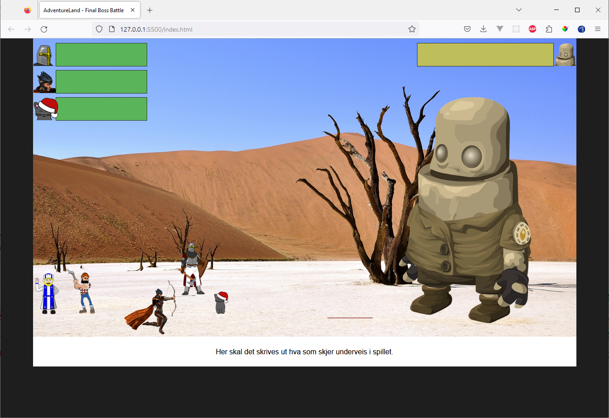

## **Part 1: Description how the game rule need to work**

## - You can click on Nameless knight, The Cat and Julia the archer to attack the monsters.

## - One makes 1 attack by clicking on Nameless knight, The Cat or Julia, and Big Boss immediately makes a return attack on one of the 3 heroes; it should be random which of them Big Boss attacks.

## - Sometimes (with a probability of 25%) after making an attack, a Slime or Bat will appear (ref. img with id appearing-monster).

## - All attacks should take a random amount of hp; use the Math.random technique.

## - When Slime or Bat has appeared, the 3 heroes can only attack Slime or Bat. They don't attack back, but they prevent the heroes from being able to attack Big Boss. Big Boss continues to attack as usual while Slime or Bat is there.

## - Nameless knight only manages to kill Big Boss

## - Julia the archer only manages to kill Bat

## - The Cat can only kill Slime

## - All attacks must be printed. All prints must include how much hp is taken, for example "Big boss attacks Julia, and Julia loses 20hp".

## **Part 2: expand more functionalities**

- You can click on William the healer to heal one or more of the heroes

- Use the element.style technique to style the messages that are printed. For example, when Julia attacks, the background of the message is green.

- You have to click on Jack the lumberjack to make arrows for Julia; i.e. Julia has a limited number of arrows.

- If Big Boss has less than 20% health then he becomes bigger and takes 10% less damage.

- "You won!" should appear. if one wins over Big Boss

- A "You lost!" message should appear if you lose

- Make use of setTimeout (see code example below) to delay the attack from Big boss and the other baddies by 1-3 seconds.

- Custom functionality: add something you yourself want to include that you think is cool to include!